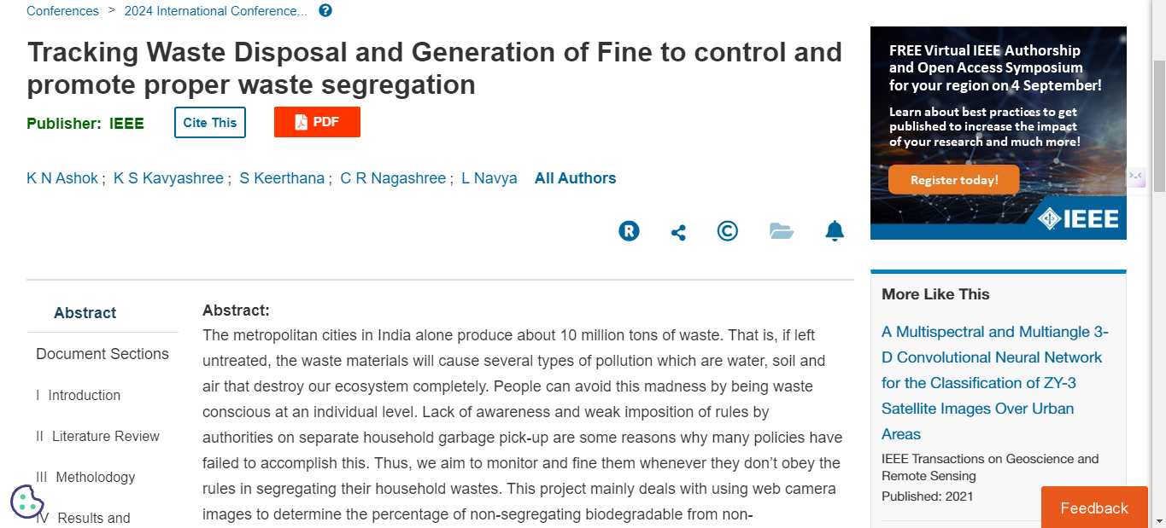

Publication link: https://ieeexplore.ieee.org/document/10616661